TASK 04

1. Open your own laptop or desktop (or use an online PC hardware simulator if you don't have access to a real system) and identify the GPU model installed. Write down the GPU's brand, model number, and whether it is integrated or dedicated.
• Brand: Intel
• Model number: Intel(R) HD Graphics 530
• Type: Integrated GPU
2. Take a clear photo or screenshot of the cooling system (fan, heatsink, or liquid cooling setup) inside your PC or from a PC hardware simulator. Label the main cooling components and briefly describe their function.
• CPU fan: Moves air across the heatsink to help cool the processor.
• Heatsink: Absorbs heat from the CPU and releases it into the moving air.
• Case fan (exhaust): Pushes hot air out of the computer case.
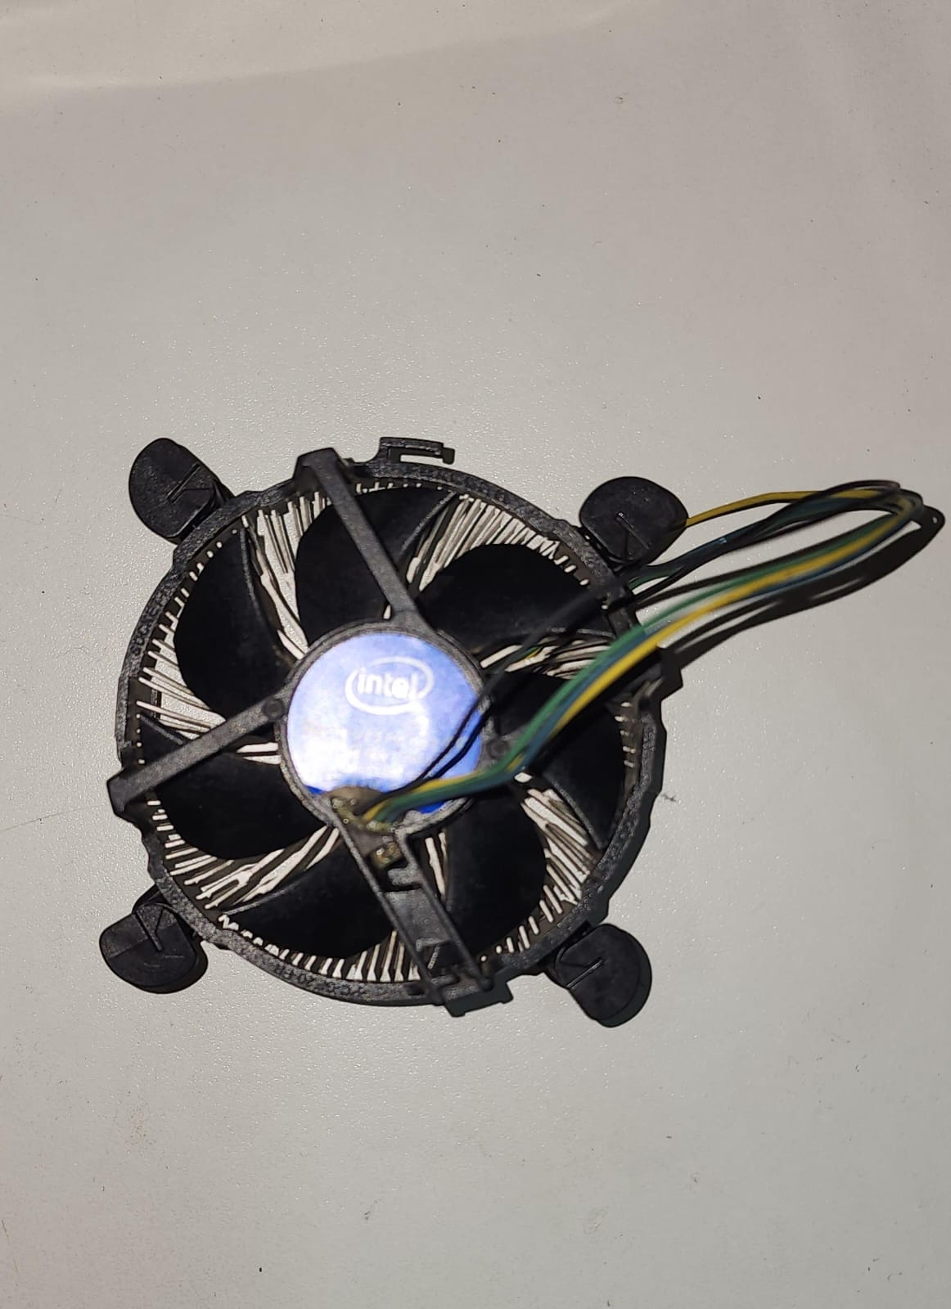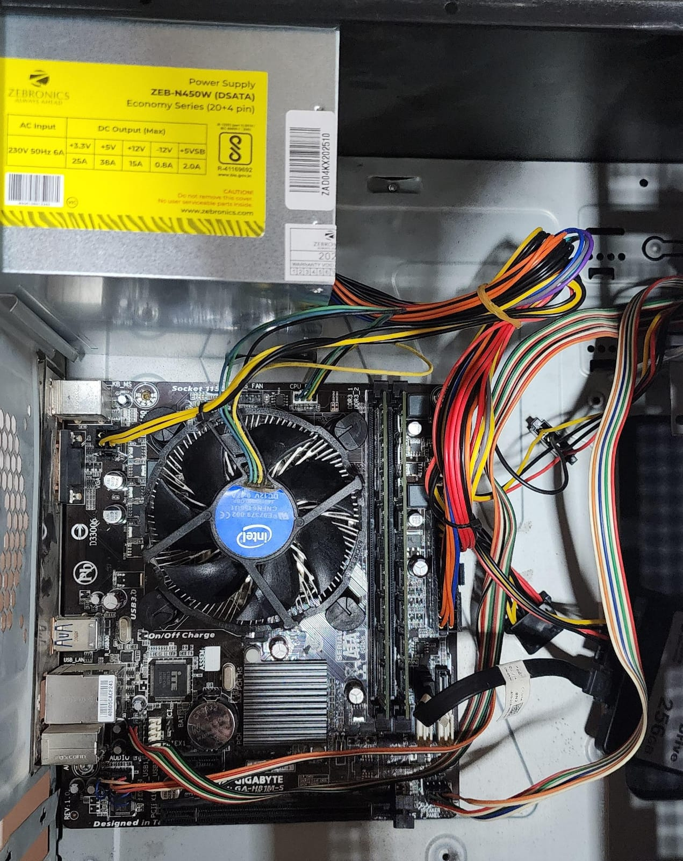
COOLING FAN

3. Create a comparison table listing at least 3 differences between air cooling and liquid cooling systems for GPUs, including factors like cost, efficiency, and maintenance.
Factor | Air Cooling | Liquid Cooling
1. Cost | Usually cheaper and more affordable. | Usually more expensive to buy and install.
2. Cooling efficiency | Effective for normal gaming and everyday use. | Can provide better cooling for high-performance GPUs, depending on the setup.
3. Maintenance | Low maintenance; mainly requires dust cleaning. | May require more maintenance, especially for custom loops.

4. Imagine you are building a gaming PC for streaming IPL matches and playing graphics-heavy games. Choose between air cooling and liquid cooling for your GPU, and justify your choice in 3-4 sentences based on your research.
I would choose liquid cooling for a gaming PC used to stream IPL matches and play graphics-heavy games. It can provide excellent cooling for high-performance GPUs during long gaming sessions and help maintain stable temperatures. However, liquid cooling usually costs more than air cooling and may require more complex installation and maintenance.

